**PROJECT PROPOSAL**

**PROBLEM STATEMENT**

Zomato is a multinational restaurant aggregator and food delivery company founded by Deepinder Goyal and Pankaj Chaddah in 2008. Zomato provides information, menus and user reviews of restaurant as well as food delivery options from partner restaurant in select cities. As of 2019 service is available in 24 countries and in more than 1000 cities.

Let’s consider you are a product manager at a company like Zomato. To release any feature, let’s say you have four or five steps like ideation, design, implementation, testing and deployment. And you have 3-4 features like rate/review restaurant, filters for search, online ordering, etc. in line for next release. Write a medium post on how you would go about the development of these features using the Agile methodology, incremental and iterative way of development.

The ability to understand the problem, frame problem statements, generate hypotheses, define key metrics and provide tangible solutions is integral to any analyst job. Below are the question which are part of my problem statement.

1. How to increase AOV (average order value)?
2. How to reduce delivery costs?
3. Is it feasible to deliver multiple orders during single delivery and which cuisines or restaurants can be targeted for a POC (proof of concept)?
4. For a particular month, say December the ice and desserts orders reduced. What’s the root cause?
5. For a fixed budget of $10M to provide 10X growth on hyper pure should tier 1 or 2 or 3 cities can be targeted?
6. For a city, Pune, the overall delivery ratings are low. What could be the reasons?
7. Which restaurants should be used for customer acquisitions?
8. Yearly about 25%of restaurants in India shut down. Hoe can Zomato prevent such a situation on its platform?
9. What metrics can be measure customer retention and customer satisfaction apart from rating and reviews?
10. What factors need to be considered while looking for an apt location to open a cloud kitchen in a Tier 1 city vs Tier 2?

**INTRODUCTION**

Founded in 2008 Zomato is a major food delivery aggregator with a markdown cap of 1 trillion INR. It started as Foodie Bay, a restaurant recommendation product, at its peak, it has 35000 menus and Rs 60 Lakh monthly revenue. Foodiebay.com reroutes to zomato.com now.

Swiggy is the major competitors in India, offering the same services as Zomato. But Zomato is ahead of swiggy with respect to its AOV by RS 35 according to a 2020 Goldman Sachs report. This gives Zomato a shot in the arm to break even and be profitable as the higher the AOV higher the margins. The importance of high AOV will be explained in the later section.

Zomato has either invested or acquired in quite a few startups internationally to help grow its business, the recent one being grofers – Gurugram based online grocery firm. This helps Zomato focus mainly and food delivery and lets grofers handle daily usage products. Swiggy its counterpart has swiggy mart which handles grocery delivery. Zomato believes it can provide its shareholder better value by investing in another firm than building its own grocery product.

**DATASET.**

So, I have a dataset of more than 9000 restaurants in different cities in different countries which provide Zomato delivery so I have uploaded some screenshot below.

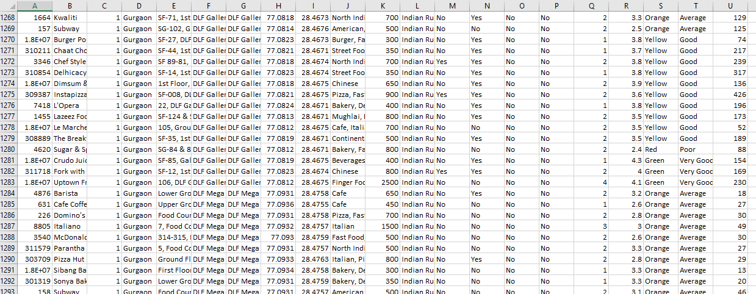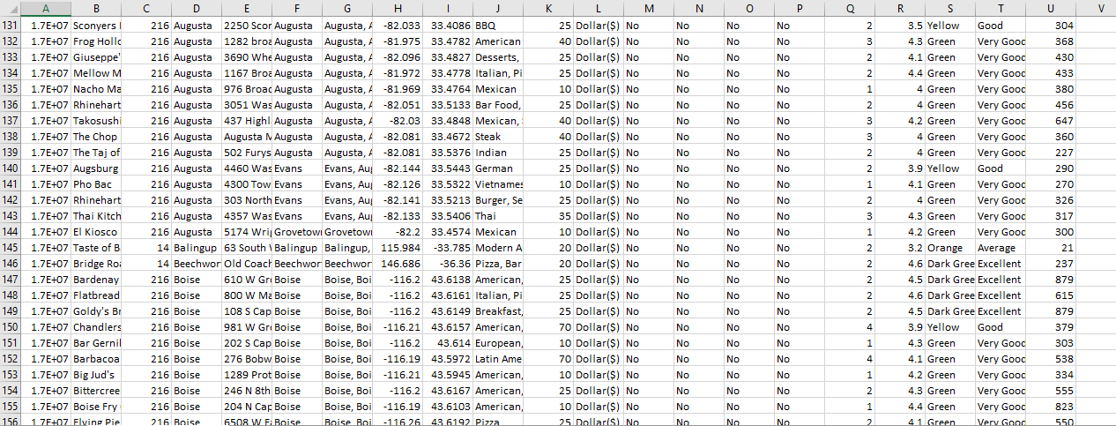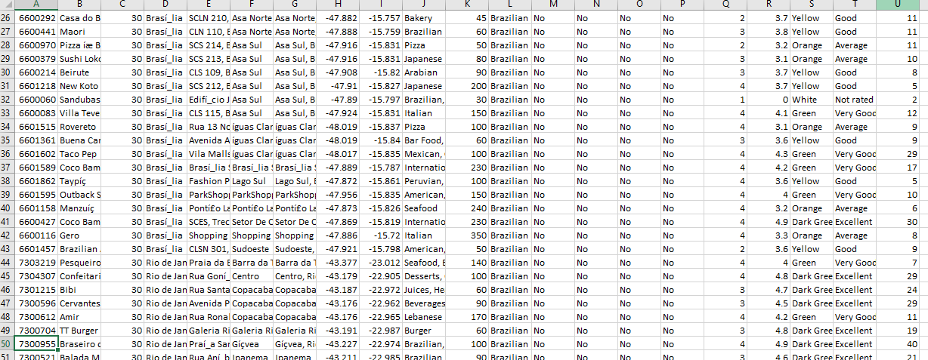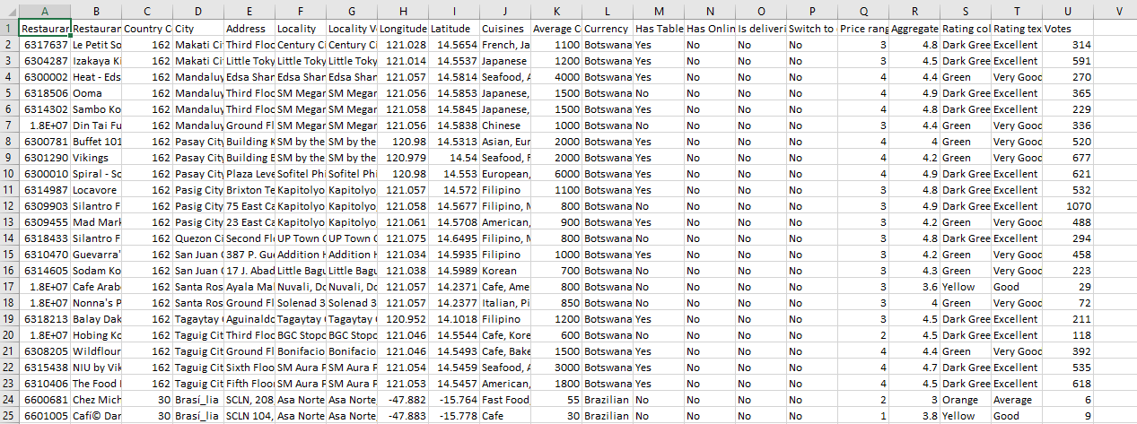

**METHODOLOGY.**

With the present dataset, interesting insights pertaining to geography, restaurant type and rating van be generated. So I have used tableau for exploratory data analysis and data visualization using tableau. Tableau is easy drag and drop tool and is quite helpful in EDA’s.

Even I worked on predictive analysis on Zomato data so that customer experience can be enriched, also to reduce cost or increase revenue. i.e., machine learning.

Thank You.